**ICT1222 - Database Management Systems Practicum Mini Project**



**Department of Information and**

**Communication**

**Technology Faculty of Technology University of Ruhuna**

**Database Management Systems Practicum (ICT 1222)**

**Assignment 02 – Mini Project Group 16**

Submitted to: Mr.P.H.P. Nuwan Laksiri

Submitted by: H.D.P.S.Fernando TG/2022/1343

I.P.G.Sankalpana TG/2022/1349

ALM.Hajith TG/2022/1414

|  |
| --- |
| - |

**Database Name: SIMS (Student Information Management System)**

**Included tables:**

1. **Student table**
2. **Course Table**
3. **Lectures Table**
4. **Users Table**
5. **Student Attendance**
6. **Student Eligibility**
7. **Student Grade**
8. **Student Performance**
9. **Student Marks**
   1. **Server-side Web Development**
   2. **DBMS practical**
   3. **DBMS theory**
   4. **Computer architecture**
   5. **Computer Network**
   6. **Discrete Mathematics**
   7. **Fundamentals Of Management**
   8. **English**

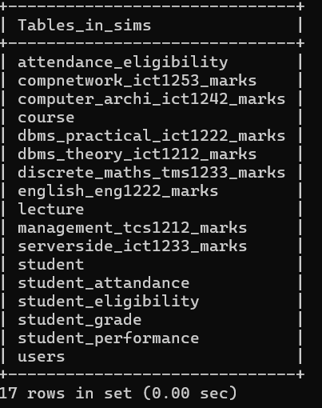

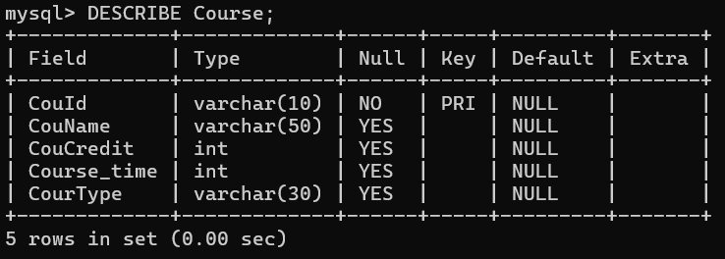**EVERY TABLES STRUCTURES**

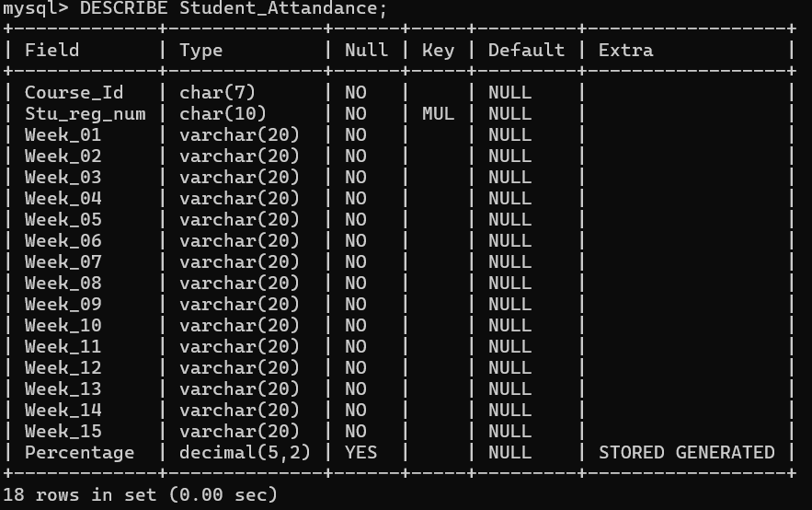

Created Procedures and Views

Attendance Eligibility view

Name: attendance_eligibility

Purpose: Users can see all students attendance eligibility

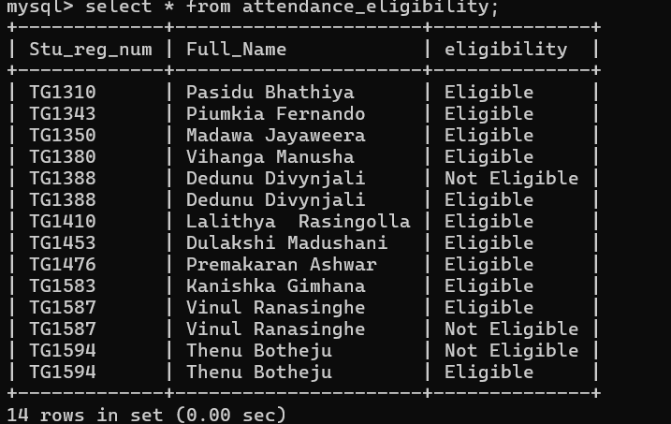

Name: GetStudentDetailsByBatch

Type: Procedure

Purpose: When user enter the batch type as “proper” or “repeat” it returns the student name, id, corses, grades , SGPA, and CGPA.

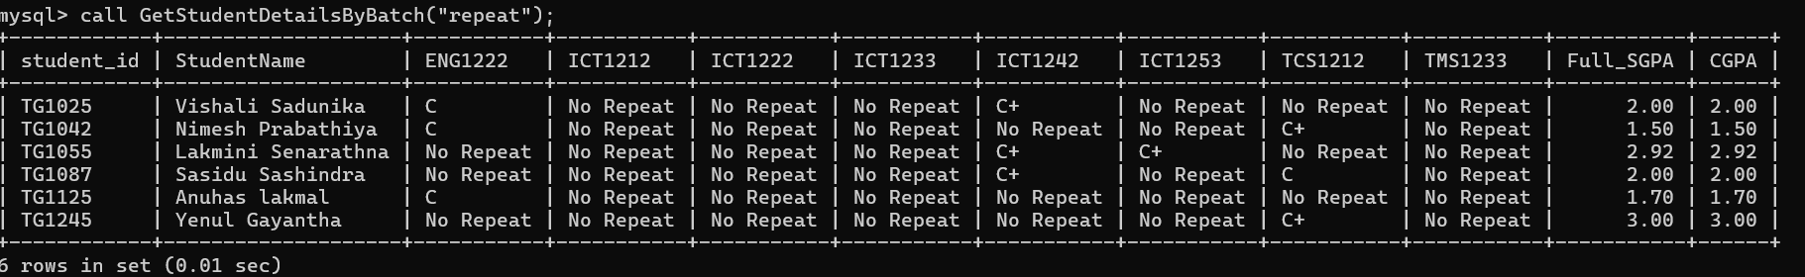

Name: InsertStudentGrade_ENG1222_Marks

Type: Procedure

Purpose: It uses generate grade and GPA and grade with the reference of course marks table.

Course Id “InsertStudentGrade_Each course id_Marks” very like each table in this procedure